Story Response - Story Stiffness

Summary Description
This is story response output for a specified range of stories and a selected load case or load combination.

Input Data
Name | StoryResp2
Display Type | Story stiffness | Story Range | All Stories
Load Case | RS | Top Story | Story6
Output Type | Not Applicable | Bottom Story | Base

Plot
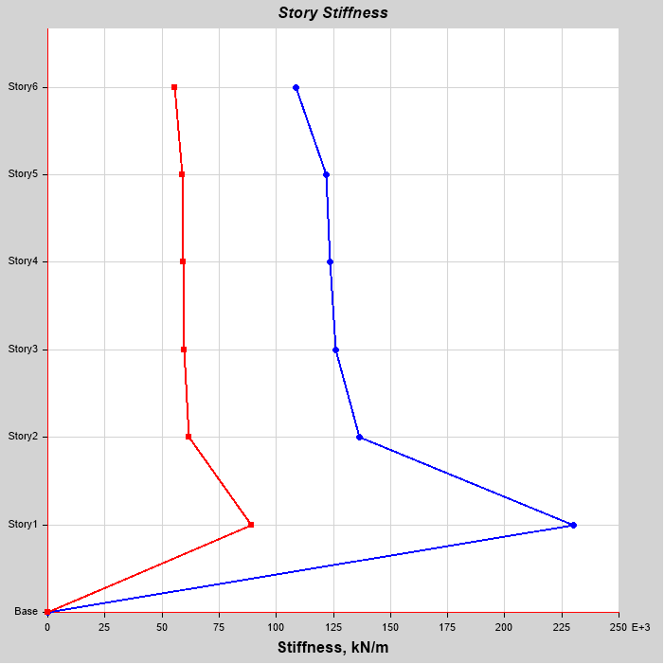

Tabulated Plot Coordinates
Story Response Values

Story | Elevation | Location | X-Dir | Y-Dir
 | m |  | kN/m | kN/m
Story6 | 18 | Top | 108559.537 | 55608.392
Story5 | 15 | Top | 121738.373 | 58936.825
Story4 | 12 | Top | 123580.409 | 59324.282
Story3 | 9 | Top | 125967.977 | 59749.252
Story2 | 6 | Top | 136485.228 | 61749.819
Story1 | 3 | Top | 230275.86 | 88986.389
Base | 0 | Top | 0 | 0

